Software Requirements Specification

for

Fish Tank Monitoring System

**Version 1.0 approved**

**Prepared by Mohamed Sarraj and Shanaaz Ahamed**

**Team Binary**

**23.05.2022**

**Table of Contents**

**Table of Contents ii**

**Revision History ii**

**1. Introduction 1**

1.1 Purpose 1

1.2 Document Conventions 1

1.3 Intended Audience and Reading Suggestions 1

1.4 Product Scope 1

1.5 References 1

**2. Overall Description 2**

2.1 Product Perspective 2

2.2 Product Functions 2

2.3 User Classes and Characteristics 2

2.4 Operating Environment 2

2.5 Design and Implementation Constraints 2

2.6 User Documentation 2

2.7 Assumptions and Dependencies 3

**3. External Interface Requirements 3**

3.1 User Interfaces 3

3.2 Hardware Interfaces 3

3.3 Software Interfaces 3

3.4 Communications Interfaces 3

**4. System Features 4**

4.1 System Feature 1 4

4.2 System Feature 2 (and so on) 4

**5. Other Nonfunctional Requirements 4**

5.1 Performance Requirements 4

5.2 Safety Requirements 5

5.3 Security Requirements 5

5.4 Software Quality Attributes 5

5.5 Business Rules 5

**6. Other Requirements 5**

**Appendix A: Glossary 5**

**Appendix B: Analysis Models 5**

**Appendix C: To Be Determined List 6**

**Revision History**

| **Name** | **Date** | **Reason For Changes** | **Version** |
| --- | --- | --- | --- |
|  |  |  |  |
|  |  |  |  |

# Introduction

## Purpose

*The purpose of this document is to provide a detailed and sufficient description of our fish tank monitoring system. It will explain the purpose and features of this system, what the system will do, the constraints the system will operate on, how the system will react to a change.*

## Document Conventions

*This document use the following conventions*

*OCR - Optical Character Recognition*

*API - Application Programming Interface*

*DB - Database*

## Intended Audience and Reading Suggestions

*This document is intended for students, interested readers,embedded devices related enthusiasts and also who have fish tanks. The upcoming parts of the document describe the scope, description about the system, features, and functional and non-functional requirements.*

## Product Scope

*Fish and other aquatic animals need a balanced pH for survival. This pH value can make fish sick and even kill them. Therefore, we are proposing a system for fish tanks which monitors the value using the pH probe,BNC connector,AtoD converter and Raspberry Pi and alerts the specific person’s mobile using notification.Thereafter we can add baking soda to raise the pH and add peat moss to lower the pH value or simply change the water. Turbidity is another key characteristic that determines the lifespan of fishes and also affects the beauty of the fishtank. Therefore, We do check the turbidity of water using the camera and image processing. In addition to that we propose an automated feeding system at regular intervals.We will develop a simple mobile app showing the status of the fish tank. This document provides the details of the fish tank monitoring system which would simplify our task and monitor the quality of the fishtank and improve the lifespan of fishes. This is a simple system capable of monitoring pH value and turbidity and also a feeding sub-system.*

## References

[*https://web.cs.dal.ca/~hawkey/3130/srs_template-ieee.doc*](https://web.cs.dal.ca/~hawkey/3130/srs_template-ieee.doc)

[*https://krazytech.com/projects*](https://krazytech.com/projects)

# Overall Description

## Product Perspective

*This would be a new system consisting of the above mentioned three subsystems.*

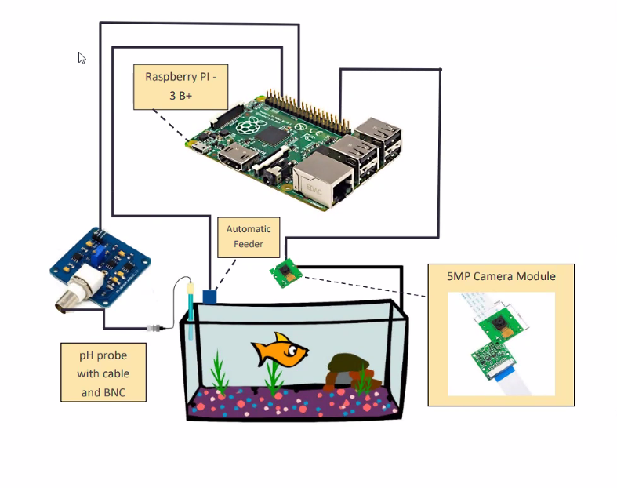

## Product Functions

*Smartphone App - This will display the PH value and status, available feed status and percentage and the status of the turbidity whether good or bad*

*feeder - This will supply the feed continuously by opening and closing the lid at regular intervals using the servo motor*

*Raspberry Pi will take readings of PH probe and determine the value whether good or bad water.*

## User Classes and Characteristics

*The user involvement is lower in this system as the only task to do by a user is to initialize the system and clean the Ph probe once a month.*

## Operating Environment

*The system will use the Raspberry Pi for the integration of the sensors, camera module and the servo motor.* 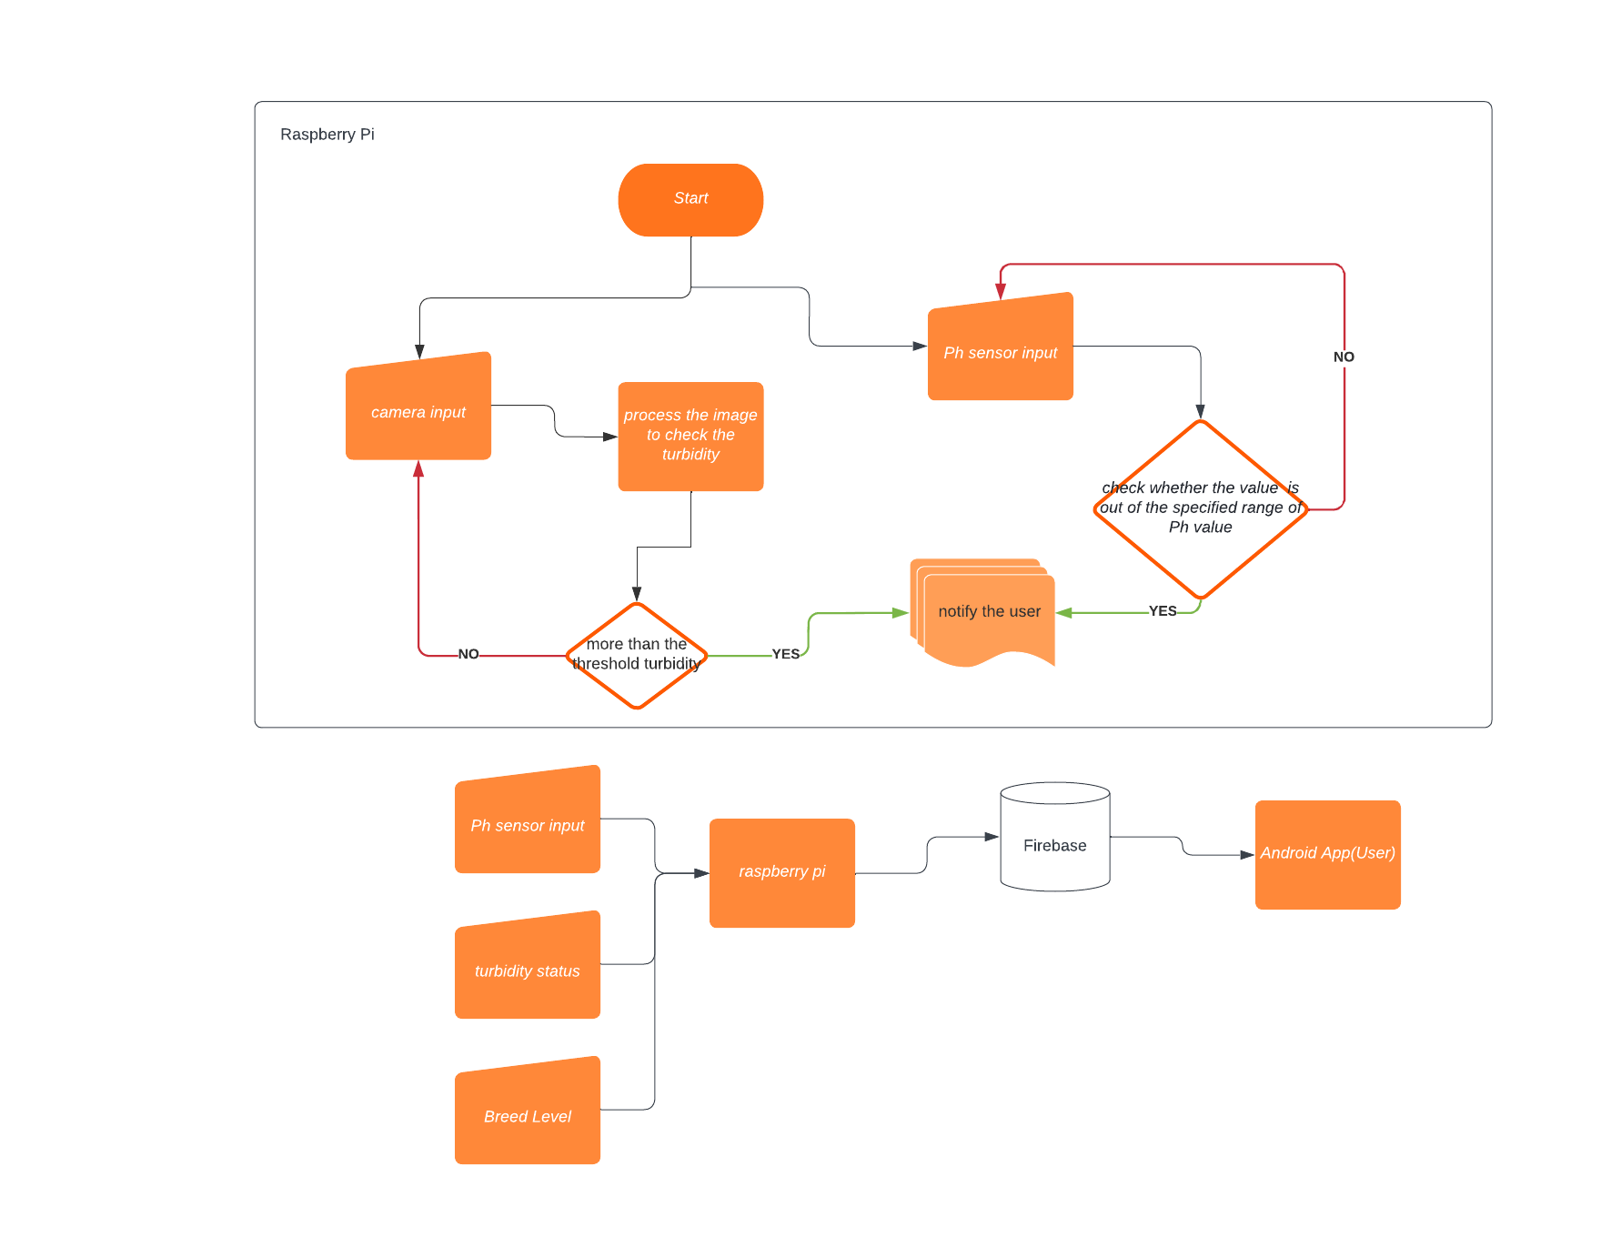

## Design and Implementation Constraints

*As the Raspberry by 3B+ has 1GB of RAM and the limited processing capability it may take some time to process the image and produce the result. As the pH probe is an analog sensor we need an additional IC (ADS1115) to change the analog signal into digital signal.*

## User Documentation

*User only needs to install the application and run in the background*

## Assumptions and Dependencies

*The camera module is 5-megapixel quality, and it needs proper lighting and the constant same lighting for better results. PH sensor also need to be calibrated and we must assume in that it’s calibrated when we take readings*

# External Interface Requirements

## User Interfaces

**Android Application**

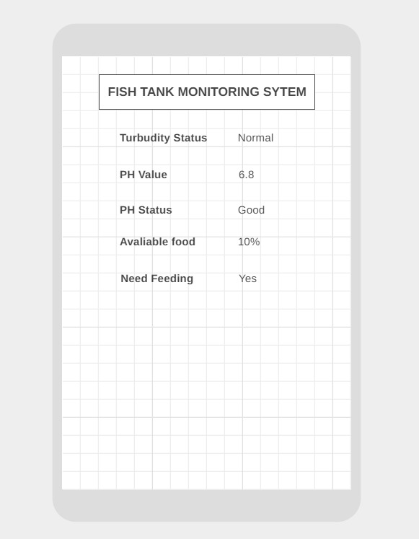

## Hardware Interfaces

*We will assign a button to enable the feeder to feed the fish manually when needed. The PH sensor reading, turbid status determined by the image processing and the feed level in the feeder using ultrasonic sensor will be sent to Firebase from raspberry Pi and it will be displayed in the mobile App.*

#### Raspberry Pi Model 3 B +

Raspberry Pi is our centralized system which integrates all sensors, processes the image, and sends the data to firebase.

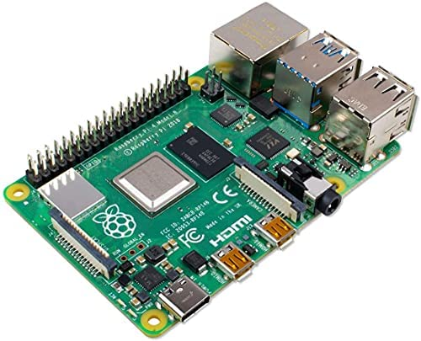

* + 1. **Ultrasonic Sensor HY-SRF05**

We use ultrasonic sensors to measure the feed level of the fish feed using the distance of detection of objects inside the feeder bottle.

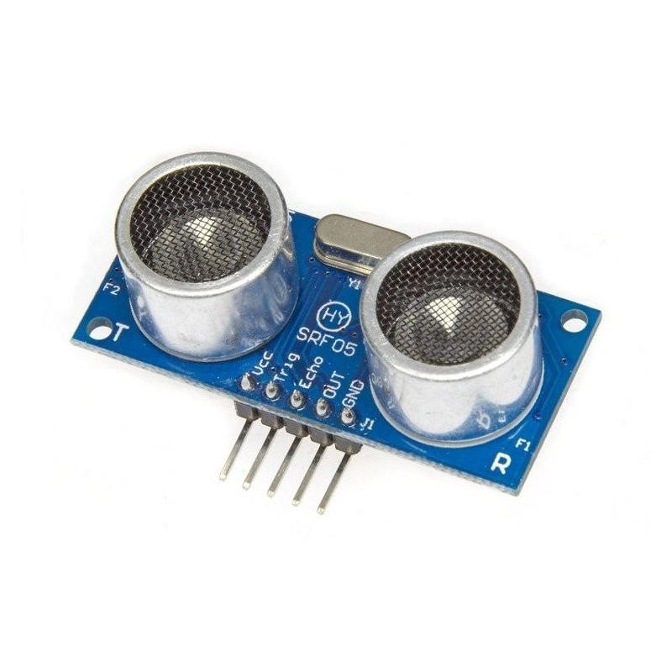

* + 1. **Servo Motor SG-90**

The servo motor is used to open the lid of the feeder bottle in a particular time interval. It is connected to the raspberry pi 5v vcc. It will only open if there is food available in the bottle.

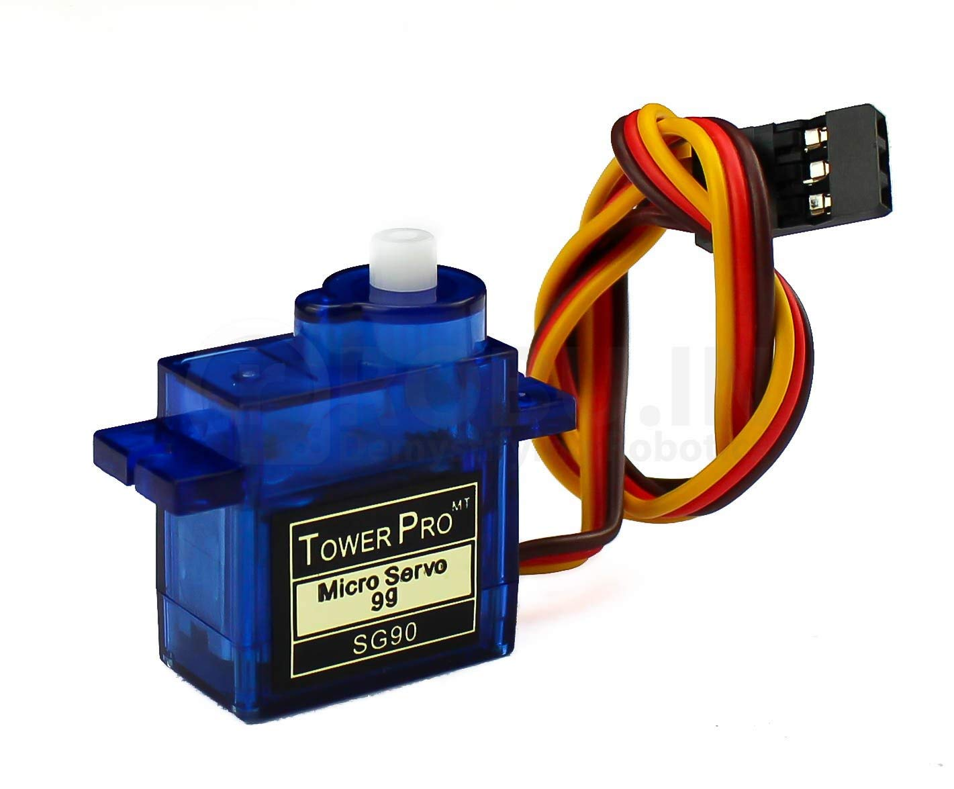

* + 1. **5MP Raspberry Pi Camera**

We use a 5 MP camera Module to take pictures of words we place inside the water to detect the turbidity using OCR method.

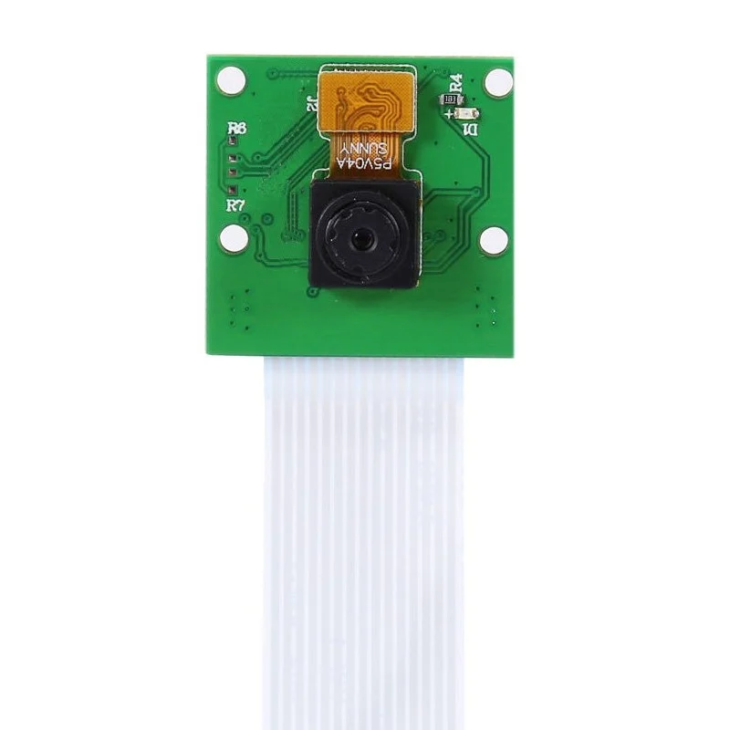

* + 1. **pH Electrode Sensor with BNC Connector**

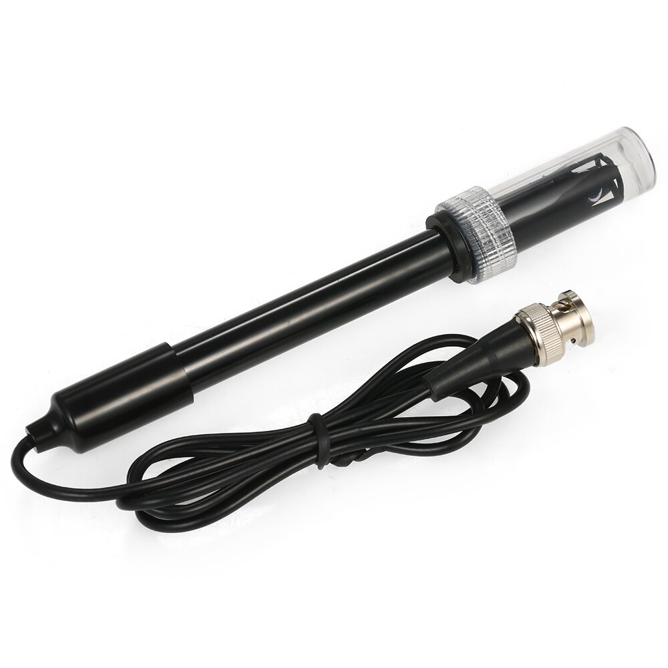

PH probe with BNC connector used to measure the ph value of the water. The output of the BNC connector gives an analog signal. Raspberry pi doesn't have an inbuilt analog pin. Therefore, We used an analog to digital converter to convert the signal. Freshwater fish survival PH value is 5.5 - 8.5.

Therefore, if the PH value is less than or greater than the above ph interval, Raspberry pi will send a notification to the Android App.

* + 1. **Analog-to-digital converter ADS1115**

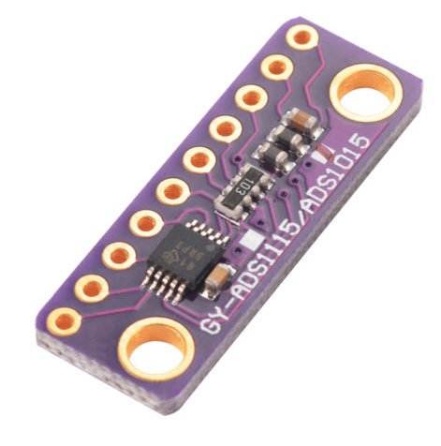

The ADS 1115 is used to convert the analog signal to digital signal because Raspberry pi doesn't have an inbuilt analog pin.

## Software Interfaces

*Our mobile app will run on an Android platform(5.0 Lollipop +) and it is connected to Firebase by Google. Raspberry Pi will run on Raspbian GNU/Linux 10(buster). We need Android Studio for the development of mobile apps.*

## Communications Interfaces

*it requires Firebase for communication between raspberry pi and mobile App. We use I2C protocol for pH sensors.*

# System Features

## System Feature

*The system should continue running on a loop and it will notify immediately when the water turbidity or the pH value changes, and they should not stop the motor should be working correctly in that particular interval and feed the fish breed*

**Functional Requirements**

*The system should capture the image and send it to the Raspberry Pi and the Raspberry Pi should process the image using the OCR and check the tablet level using the OCR under threshold values and provide the result.*

*The system should take the pH value input from the pH probe and convert it to digital input and check with the required pH range whether this is suitable or not and notify the user to change the water when it is outside the range.*

*The automatic fish feeder should operate at regular intervals and feed the fish tank and also it should notify when the lower amount of breed is present.*

# Other Nonfunctional Requirements

## Performance Requirements

*Performance should be at optimum level as mentioned above as the Raspberry Pi has 1GB of RAM. Mobile should have a later Android version (Lollipop 5.0 or later).*

## Safety Requirements

*Raspberry Pi should be covered with a protective cover as it is placed near the fish tank and the humidity of the area might affect the Raspberry Pi.*

## Software Quality Attributes

*have a simple and user friendly GUI and have a fast response, push notifications at every warning*

## security requirements

*sensor data should be sent through a reliable data transfer connection*

# Other Requirements

*There should be a good internet connection, space to place the Raspberry Pi*

**Appendix A: Glossary**

*Firebase - Firebase is Google’s mobile application development platform that helps you build,*

*improve, and grow our app.*

*protocol - set of rules divided between two or more for communication*